**4 Investment Strategies During A Recession**

A recession is a general decline in economic activity over an extended period. Many define a recession as two consecutive quarters of negative GDP growth.

Since the pandemic outbreak many investors are looking for strategies to protect or even grow their investment account but they find out that high volatility periods (like this one) often return higher risks and rewards.

1. Do Not Dump All Stocks

When a recession hits, stocks underperform in the near term. But while it may seem like a good idea to sell all the stocks in your portfolio, selling them when they are down is rarely a good idea. Also you can look for stocks that make sense in the near future. For example, you can invest in medicine, consumer goods or even airlines if your time horizon is a little longer.

2. Raise Cash

One of the best ways to get defensive during a recession is to increase your cash position. Cash provides the ultimate flexibility and the most peace of mind when times get tough in the market. Even if the market is highly volatile a strong currency will not fluctuate as much because central banks are applying their monetary policy measures.

3. Buy Dividend Stocks

Dividend stocks are recession proof assets that are prefered by income investors. The only thing you must watch out during an economic downturn is dividend cuts.

To minimize the risk of buying a stock in danger of a dividend cut, look for stocks with positive free cash flow, stable earnings, low debt levels and a relatively low payout ratio.

4. Buy Gold or other “as gold” assets

Luckily, this is not the first recession and we can analyze the past to see which asset performed well and which not. Over the years gold performed well even in difficult times but the question is why? Why an asset apparently useless could grow its value since antiquity?

The answer is simple, because it is not backed off by any institution or country, gold belongs to everyone and no one. People will always feel the need to save for bad days and they will feel more comfortable to store their value in an asset that performed for so long and is somehow “independent”. Nowadays, gold is not the only asset dependent only on supply and demand. Some people are comparing gold with bitcoin and it makes sense, you get the same qualities and many more in a virtual pocket which may be the future.

To sum up, there are a lot of opportunities out there and there will always be, so take care when you are making investment decisions, do your own research and be patient. Peace:)

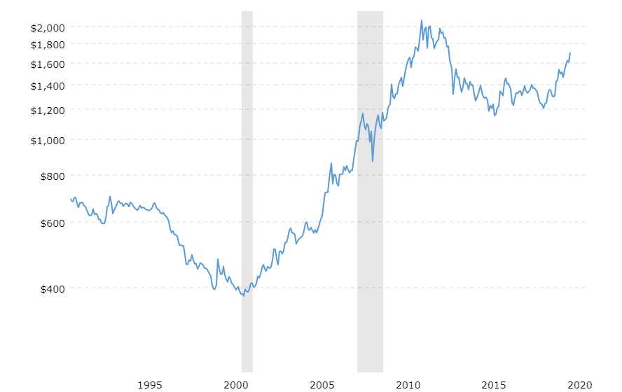

Gold price over 30 years with highlighted recession periods.